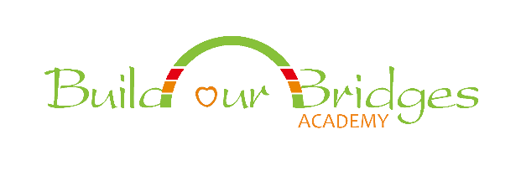

**The 2020-2021 President's Volunteer Service Award Application**

**by Build Our Bridges Academy**

March 7, 2021

**Build Our Bridges Academy is a non-profit 501(c)(3) organization in California. Our mission is to:**

1. help people from different groups, including countries, cultures, races, genders, and classes

to build bridges;

2) create a lifelong learning community through quality educational programs; and

3) Inspire and empower people, especially middle/high school students and their parents, to

develop leadership at home, in schools and communities and around the world.

**The President's Volunteer Service Award** **(PVSA)** was developed to honor Americans (citizens or green-card holders) who have provided significant service to their schools, communities, and the world through their leadership, time, actions, and talents.

**To apply for this award:**

1. Pleaseread the following information carefully:

***Volunteer Eligibility***

* United States citizen or lawful permanent resident of the United States (i.e., green card holder).
* Complete eligible service within a 12-month period between March 20, 2020 to March 20, 2021 (for annual Bronze, Silver, and Gold Awards) and over a lifetime (for Lifetime Achievement Awards).

***Eligible Service:***

Unpaid acts of volunteer service benefiting others:

* + Service through National service programs that provide a stipend (e.g., Peace Corps, AmeriCorps) may count towards the Lifetime Achievement Award, but not for the annual Bronze, Silver, and Gold Awards);
  + Travel stipends, transit/parking passes, membership passes, expense reimbursements, and other nominal volunteer support do not impact service eligibility.

***Eligible Service does not include*:**

* Donating funds
* Political lobbying (Non-partisan voter registration is an eligible activity)
* Religious instruction
* Conducting worship service
* Proselytizing
* Volunteer service performed as part of court-ordered community service
* Serving only family members

|  |  |  |  |  |
| --- | --- | --- | --- | --- |
| **Hours Required to Earn Awards in Each Age Group** | | | | |
| **Age Group** | **Bronze** | **Silver** | **Gold** | **Lifetime Achievement Award** | |
| Kids (5–10 years old) | 26–49 hours | 50–74 hours | 75+ hours | 4,000+ hours | |
| Teens (11–15) | 50–74 hours | 75–99 hours | 100+ hours | 4,000+ hours | |
| Young Adults (16–25) | 100–174 hours | 175–249 hours | 250+ hours | 4,000+ hours | |
| Adults (26+) | 100–249 hours | 250–499 hours | 500+ hours | 4,000+ hours | |

**2.** Fill out the attached forms with background and other information including the total volunteer hours.

**3.** Organize the total service hours by each organization and put the summary page for each organization at the beginning.

**4.** Include all the information in a package and send them to us by **March 22** (postmark: March 22, 2021) to: Build Our Bridge Academy, 555 Peters Ave. Ste 110, Pleasanton, CA 94566.

Do not use the same hours to apply at two different organizations. Please come and join our annual celebration at the Award Gala from 8:00pm to10:00pm PST on Saturday June 19th. If you have any questions or concerns, let us know ([amyliuus@yahoo.com](http://amyliuus@yahoo.com)). We are here to help you.

Sincerely,

Amy Liu, Ph. D.

CEO, Building Our Bridge (BOB) Academy

Chairman, Board of Directors

Vera Wu, Secretary and Board Member,

Build Our Bridge Academy